ASSIGNMENT – 11
Q1. Implementation of Breadth-First-Search Algorithm.
#include <stdio.h>
#include<stdlib.h>
#define MAX 100
int queue[MAX], front=-1, rear=-1;

void enqueue(int v){
queue[++rear] = v;
if(front == -1) {
front = 0;
}
}

int dequeue(){
return queue[front++];
}

int isEmpty(){
return front > rear || front == -1;
}

int main(){
int n;
printf("Enter number of vertices: ");
scanf("%d",&n);

int adj[n][n];
printf("Enter adjacency matrix:\n");
for(int i=0;i<n;i++)
for(int j=0;j<n;j++)
scanf("%d",&adj[i][j]);

int visited[n];
for(int i=0;i<n;i++) visited[i]=0;

int start;
printf("Enter starting vertex: ");
scanf("%d",&start);

enqueue(start);
visited[start]=1;

printf("BFS Traversal: ");
while(!isEmpty()){
int v = dequeue();
printf("%d ",v);

for(int i=0;i<n;i++){
if(adj[v][i]==1 && !visited[i]){
enqueue(i);
visited[i]=1;
}
}
}
return 0;
}
Output:
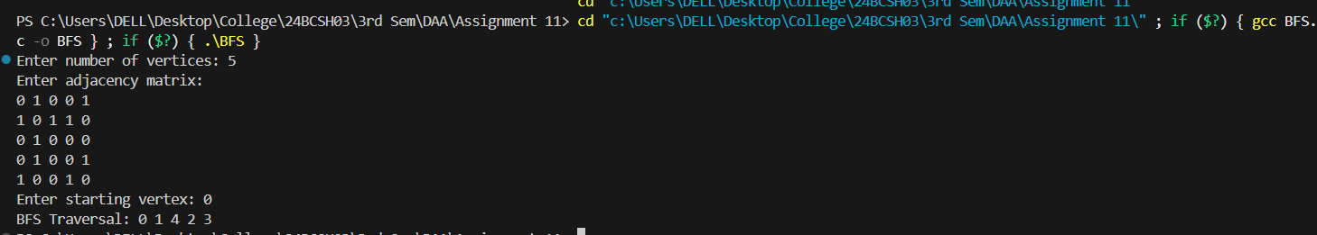

Q2. Implementation of Depth-First-Search Algorithm.

#include <stdio.h>
#include<stdlib.h>

int adj[100][100];
int visited[100];
int n;

void DFS(int v){
visited[v]=1;
printf("%d ",v);

for(int i=0;i<n;i++){
if(adj[v][i]==1 && !visited[i])
DFS(i);
}
}

int main(){
printf("Enter number of vertices: ");
scanf("%d",&n);

printf("Enter adjacency matrix:\n");
for(int i=0;i<n;i++)
for(int j=0;j<n;j++)
scanf("%d",&adj[i][j]);

for(int i=0;i<n;i++) visited[i]=0;

int start;
printf("Enter starting vertex: ");
scanf("%d",&start);

printf("DFS Traversal: ");
DFS(start);

return 0;
}

Output:
